Data Manipulation
Splitting Combined Fields
Use the data “Books Borrowed - All Libraries (City of York Council)”
- Select the Data: Highlight the column containing the text you want to split (for example, Column C (Value) with Number and Text).
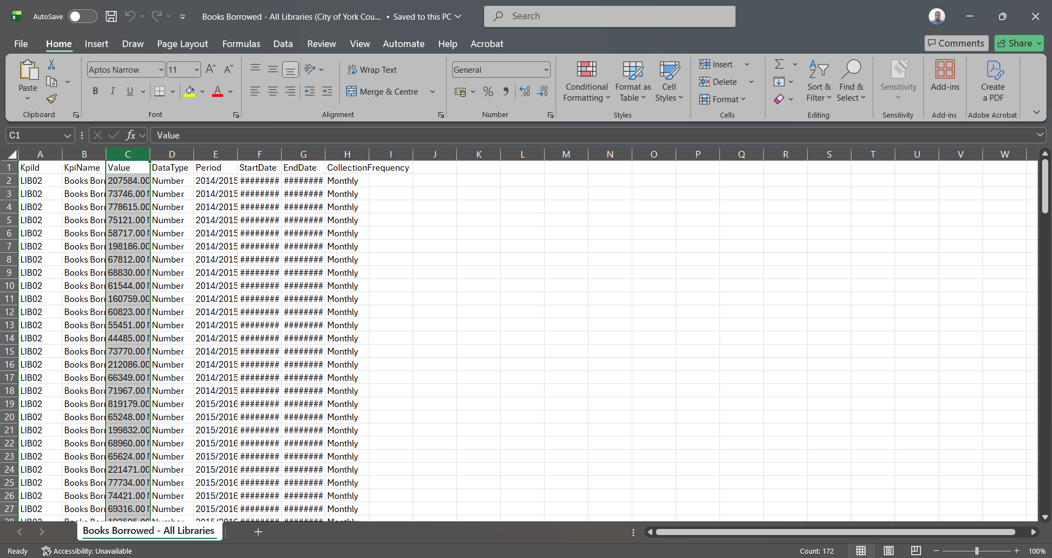

- Open Text to Columns: Go to the Data tab on the top ribbon and click Text to Columns.
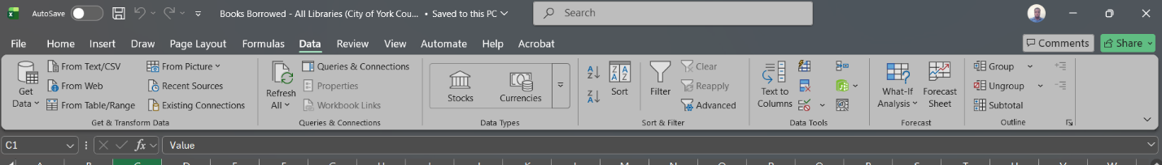
- Choose File Type: Select Delimited (because a character like a comma separates your data) and click Next.
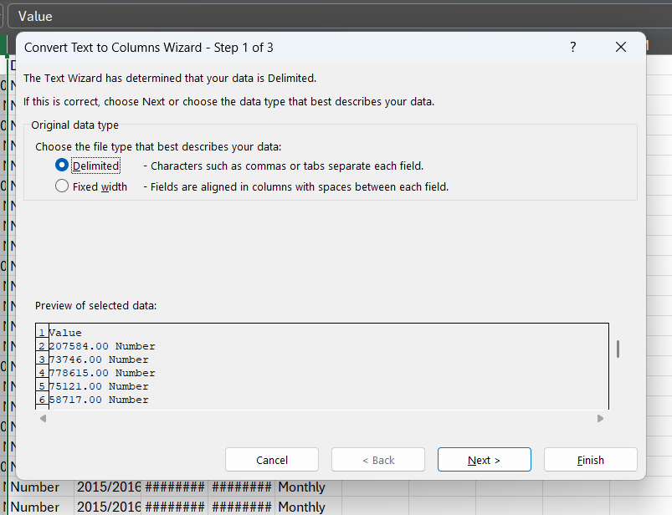

- Set Your Delimiter: Check the box for Comma (or Other if using a pipe |). Uncheck any other delimiters like Tab. You will see a preview of how the data splits at the bottom. Click Next.
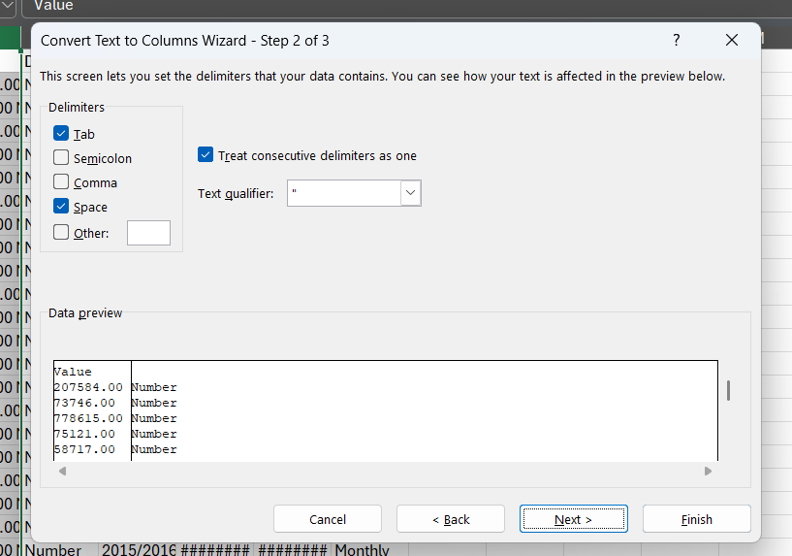

- Set Destination & Finish: In the Destination box, choose the cell where you want the split data to start (e.g., $I$1 so you do not overwrite your original column). Click Finish.
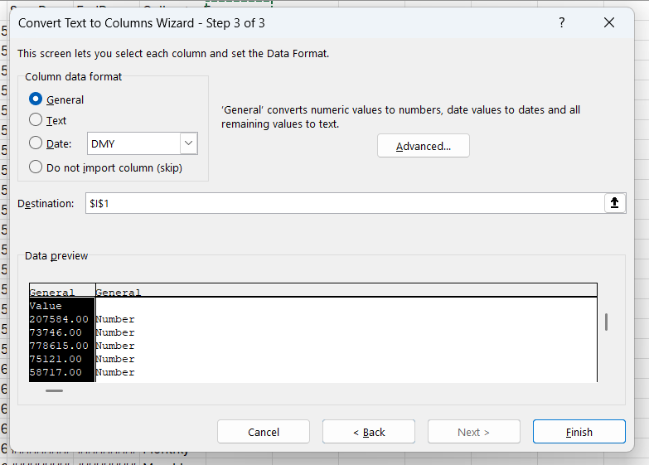

Removing Duplicates
Use the data “library_data” for practise
- Select the Data: Highlight the table or range of cells containing your entries.
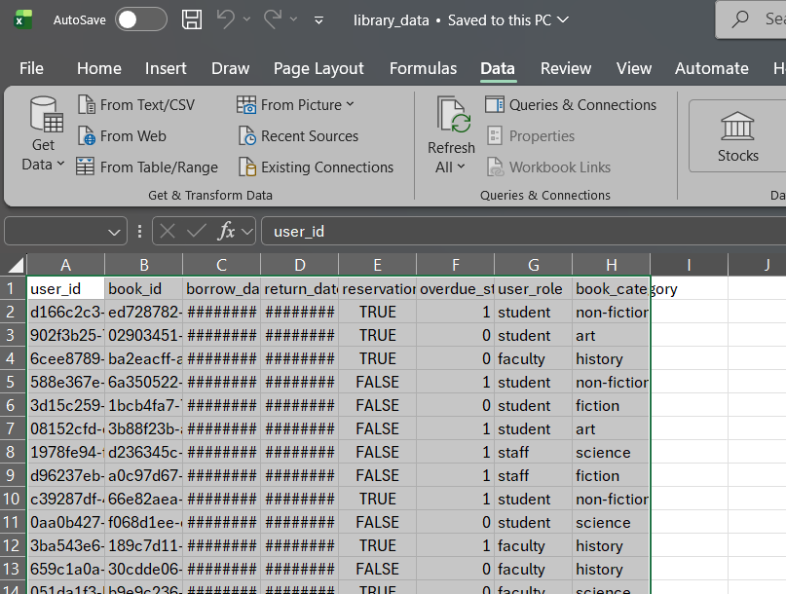

- Open Remove Duplicates: Go to the Data tab on the top ribbon and click Remove Duplicates.
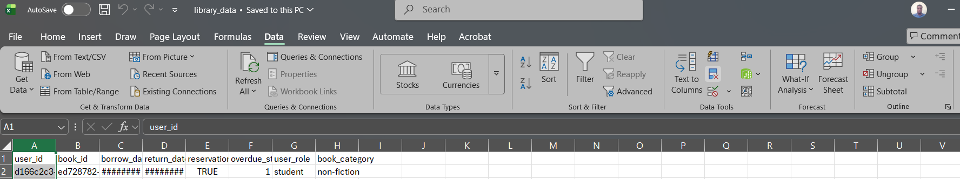

- Select Key Columns: Check the box for My data has headers if your dataset has column titles. Click Unselect All, then check only the box for your unique identifier, such as user_id or book_id.
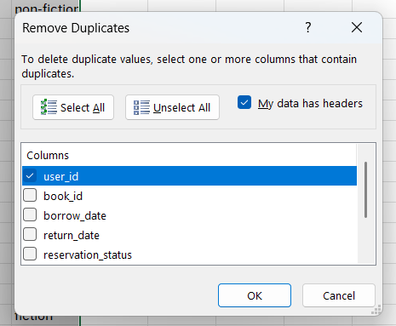

- Confirm and Remove: Click OK. Excel will process the range and display a notification showing how many duplicate values were removed and how many unique values remain.
